9.6 Solution:

a). Based on the scatter plot (attached as excel file 9.6) between Long-Term Debt and Long-Term Assets, there is linear relationship between these two. As Long-Term Assets value increases Long-Term Debt value is also increasing, for most of the given data points.

b). Estimated regression equation:

LTD = -7.84048 + 0.812132 LTA

LTD – Long Term Debt

LTA – Long Term Assets

c). The value of R2from regression analysis is 0.8497.

The value of R2 indicates that the variation in LTD is indicated by the value of LTA.

d). Total Assets of the client = 50

Estimated value of LTD for the client using the TREND function= 32.766

Standard Error from the regression analysis = 4.284

Calculated value of Standard Prediction error = 4.461

t-value for a 95% confidence interval = 2.228

Based on the above values Lower and Upper limits of the prediction interval are calculated and these values are:

Lower limit = 22.826

Upper Limit = 42.706

Note: All the values for problem (d) are calculated in the Excel sheet named Mining Data.

9.11 Solution:

a) The scatter plot between nursing salaries Y and number of beds X1

Enter the data for both Y and X1 and select the range. Below is the Output for scatter plot.

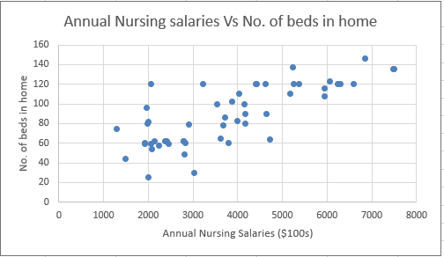

The scatter plot between nursing salaries Y and Annual medical in-patient days X2.

Enter the data for both Y and X2 in Excel and select the range. Below is the Output for scatter plot.

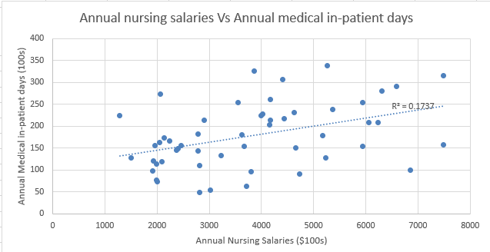

The scatter plot between nursing salaries Y and the total Annual total patient days X3.

Enter the data for both Y and X3 in Excel and select the range. Below is the Output for scatter plot.

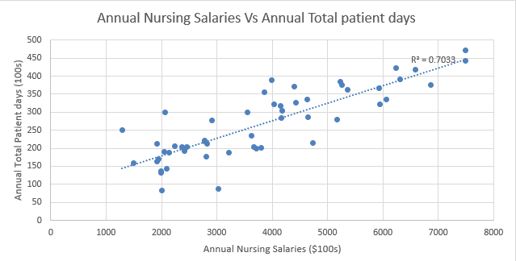

The scatter plot between nursing salaries Y and Rural (1) and non-rural (0) homes X4.

Enter the data for both Y and X4 in Excel and select the range. Below is the Output for scatter plot.

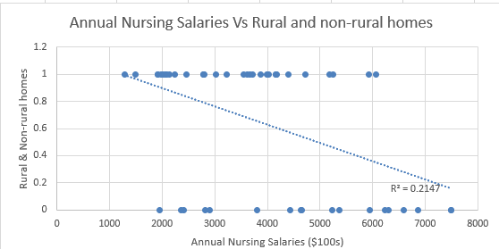

The relation between each facility (X1, X2, X3, X4) and y are describing below:

Since r value is 0.7692 for X1 and Y, the relation will be strong linear relationship between X1and Y.

Since r value is 0.4168 for X2 and Y, the relation will be moderate linear relationship between X2 and Y.

Since r value is 0.8386 for X3 and Y, the relation will be strong linear relationship between X3and Y.

Since r value is 0.4633 for X4 and Y, the relation will be strong linear relationship between X1and Y.

b)

To select one independent variable out of four to predict nursing salaries, compute the adjusted R square value of all four independent variables with nursing values. In Excel file, we need to specify the regression data and we need to specify the dependent and independent variables.

Adjusted R square (0.58) has been calculated in spreadsheet “YvsX1” for number of beds X1 and annual nursing salaries Y.

Adjusted R square (0.15) has been calculated in spreadsheet “YvsX2” for Annual medical in-patient days X2 and annual nursing salaries Y.

Adjusted R square (0.69) has been calculated in spreadsheet “YvsX3” for the total Annual total patient days X3 and annual nursing salaries Y

Adjusted R square (0.19) has been calculated in spreadsheet “YvsX4” for Rural (1) and non-rural (0) homes X4 and annual nursing salaries Y

Based on the above calculated adjusted R square values, we could see that R square for variable X3 is maximum (0.69). Hence, we should use total annual total patient days X3 to predict annual nursing salaries Y.

c)

To select two independent variables out of four to predict nursing salaries, compute the adjusted R square for each of two independent variables with nursing salaries. In Excel file, we need to specify the regression data and we need to specify the dependent and independent variables.

Adjusted R square (0.5755) has been calculated in spreadsheet “YvsX1,X2” for number of beds X1, Annual medical in-patient days X2 and annual nursing salaries Y.

Adjusted R square (0.7051) has been calculated in spreadsheet “YvsX1,X3” for number of beds X1, total annual total patient days X3 and annual nursing salaries Y.

Adjusted R square (0.6019) has been calculated in spreadsheet “YvsX1,X4” for number of beds X1, Rural (1) and non-rural (0) homes X4 and annual nursing salaries Y.

Adjusted R square (0.7555) has been calculated in spreadsheet “YvsX2,X3” for Annual medical in-patient days X2, total annual total patient days X3 and annual nursing salaries Y.

Adjusted R square (0.3486) has been calculated in spreadsheet “YvsX2,X4” Annual medical in-patient days X2, Rural (1) and non-rural (0) homes X4 and annual nursing salaries Y.

Adjusted R square (0.7075) has been calculated in spreadsheet “YvsX3,X4” total annual total patient days X3 , Rural (1) and non-rural (0) homes X4 and annual nursing salaries Y

Based on the above calculated adjusted R square values, we could see that adjusted R square value for variables X2, X3 is maximum. Hence, we should use Annual medical in-patient days X2 and annual total patient days X3 to predict annual nursing salaries Y.

D)

Adjusted R square (0.7603) has been calculated in spreadsheet “YvsX1,X2,X3” for X1, X2, X3 and annual nursing salaries Y.

Adjusted R square (0.5940) has been calculated in spreadsheet “YvsX1,X2,X4” for X1, X2, X4 and annual nursing salaries Y.

Adjusted R square (0.7123) has been calculated in spreadsheet “YvsX1,X3,X4” for X1, X3, X4 and annual nursing salaries Y.

Adjusted R square (0.7513) has been calculated in spreadsheet “YvsX2,X3,X4” forX2, X3, X4 and annual nursing salaries Y.

Based on the above calculated adjusted R square values, we could see that R square value for variables X1, X2, X3 is maximum. Hence, we should use number of beds X1, Annual medical in-patient days X2 and annual total patient days X3 to predict annual nursing salaries Y.

E)

The set of independent variables number of beds X1, Annual medical in-patient days X2, annual total patient days X3 results in high value for the adjusted R2 is maximum.

F) from sheet ‘YvsX1,X2,X3’ sheet, the regression equation is depicted as 22.3312+9.8388\*X1-7.6674\*X2+16.0213\*X3

G) from the above regression equation, the annual nursing salary is calculated in ‘sheet1’

The budget analyst should be concerned about the minimum and maximum residuals, which are 44th and 12th values in the sheet. Also the average value is 0.5 which tells that this equation is good in considering when compared to actual values